**Project Report** **On**

**Bike Renting Prediction**

-D.SOWMYA

**Content**

**Title**

**1.** Introduction

1.1 Problem Statement

1.2 Dataset

**2.** Method0logy

2.1 Pre-Processing

2.1.1 Missing Value Analysis

2.1.2 Outlier Analysis

2.1.3 Correlation Analysis

2.2 Exploratory Data Analysis

2.2.1 Bivariate Analysis

2.2.2 Feature Scaling

2.3 Modeling

**Model Selection**

Linear Regression Model

Decision Tree Regression Model

Random Forest Regression Model

KNN Regression Algorithms

**3.** Conclusion

3.1 Model Evaluation

3.2 Performance Measures

3.2.1 R Implementation

3.2.2 Python Implementation

3.3 Model Selection

**4. Appendix**

**R Code**

**Python Code**

**Chapter 1: Introduction**

1.1 Problem Statement

The objective of this project is to predict of bike rental count on daily based on the environmental and seasonal condition or settings. The given dataset has 731 observations and 16 variables in that 15 predictors and 1 target variable. The 15 predictors are the various environmental and seasonal factors like season, humidity, temperature etc. So we need to build a production-ready prediction model that predict the estimate count or demand of bikes on a particular day based on environmental and season condition.

1.2 Dataset

Our task is to build a production ready regression model that predict the number of bikes used on particular day depending on the environmental and seasonal condition.

The given dataset consist of 731 observations (rows) and 16 variables (columns) in that 15 predictors and 1 target variable. This dataset is recorded over a period of two years between 2011 and 2012. All the variables names and description is mentioned in below table:

Table 1: Description of Variables

|  |  |
| --- | --- |
| Variables | Description |
| instant | Record Index |
| dteday | Date |
| season | Season (1: Spring, 2: Summer, 3: Fall, 4: Winter) |
| yr | Year (0: 2011, 1:2012) |
| mnth | Month (1 to 12) |
| hr | Hour (0 to 23) |
| holiday | Weather day is holiday or not (extracted form Holiday Schedule) |
| weekday | Day of the Week |

|  |  |
| --- | --- |
| workingday | If day is neither weekend or holiday is 1, otherwise 0 (yes: 1, No: 0) |
| weathersit | (extracted from Freemeteo) 1: Clear, Few Clouds, Partly Cloudy  2: Mist + Cloudy Mist + Broken clouds, Mist + Few Clouds, Mist  3: Light Snow, Light Rain + Thunderstorm + Scattered clouds +Light Rain + Scattered Clouds  4: Heavy Rain + Ice Pallets + Thunderstorm + Mist, Snow + Fog |
| temp | Normalized in temperature in Celsius. The values are divided via (t – t_min)/(t_max – t_min) t_min = -8, t_max = +39 (only on hourly scale) |
| atemp | Normalized in temperature in Celsius. The values are divided via (t – t_min)/(t_max – t_min) t_min = -16, t_max = +50 (only on hourly scale) |
| hum | Normalized humidity. The values are divided to 100 (max) |
| windpspeed | Normalized windpspeed. The values are divided by 67 (max) |
| casual | count of casual users |
| registered | count of registered users |
| cnt | count of total rental bikes including both casual and registered |

The given dataset consist of 7 continuous and 8 categorical variables. Let’s see the some of the sample data of given dataset

Table 2: Sample Data

|  |  |  |  |  |  |  |  |  |
| --- | --- | --- | --- | --- | --- | --- | --- | --- |
| instant | dteday | season | yr | mnth | holiday | weekday | workingday | weathersit |
| 1 | 2011-01-01 | 1 | 0 | 1 | 0 | 6 | 0 | 2 |
| 2 | 2011-01-02 | 1 | 0 | 1 | 0 | 0 | 0 | 2 |
| 3 | 2011-01-03 | 1 | 0 | 1 | 0 | 1 | 1 | 1 |
| 4 | 2011-01-04 | 1 | 0 | 1 | 0 | 2 | 1 | 1 |
| 5 | 2011-01-05 | 1 | 0 | 1 | 0 | 3 | 1 | 1 |

|  |  |  |  |  |  |  |
| --- | --- | --- | --- | --- | --- | --- |
| temp | atemp | hum | windspeed | casual | registered | cnt |
| 0.33167 | 0.363625 | 0.805833 | 0.160446 | 331 | 654 | 985 |
| 0.363478 | 0.353739 | 0.696087 | 0.248539 | 131 | 670 | 801 |
| 0.196364 | 0.189405 | 0.437273 | 0.248309 | 120 | 1229 1349 | 1349 |
| 0.200000 | 0.212122 | 0.590435 | 0.160296 | 108 | 1454 | 1562 |
| 0.226957 | 0.229270 | 0.436957 | 0.186900 | 82 | 1518 | 1600 |

As you can see in the above table there are 15 predictors and 1 target variables. Now we put the complete list with which help us to predict the number of bikes used on particular day based on environmental and seasonal condition.

**Chapter 2: Methodology**

The solution of this problem statement is mainly divided into three parts. First was the Pre-Processing Analysis (i.e. Missing Value Analysis, Outliers Analysis, & Correlation Analysis). Second Was the Exploratory Data Analysis (Univariate, Bivariate & Feature Scaling) and last part was Modeling.

During first & second part we implement the various step like missing value analysis, outlier analysis, correlation analysis, univariate & bivariate analysis and feature scaling, etc. were performed. After that dataset is split into train and test dataset. As Target Variable ‘cnt’ is continuous numerical variable, so the problem is come under the regression model. For that reason, we used Linear Regression, Decision Tree Regression, Random Forest Regression and KNN Regression Algorithms model. Also we compare the performance of that model by implementing model on test dataset. All 4 algorithms were implement in R as well as in Python.

**Understanding the dataset**

After loading the dataset in both R and Python, we know check the number of observations and variables in it, found that there are 731 observations and 15 predictor variables and 1 target variable.

In dataset, some of the variables are not useful for further analysis for that reason we going to dropped that variables:

Dropping variables which are not required:

instant: index number, which is not useful in analysis

dteday: all the required parameters are already extracted from this variables like yr, mnth, weekday. So now this variable is not useful.

After dropping these two variables our dataset consist of 731 observations and 14 variables in that 13 predictors and 1 target variables.

**2.1 Pre-Processing**

**2.1.1 Missing Value Analysis**

The first and most important step in pre-processing analysis is Missing Value Analysis. This analysis is performed on the given dataset. We found that there is no missing values present in given dataset. Let’s check the below image for missing value count for each variables.

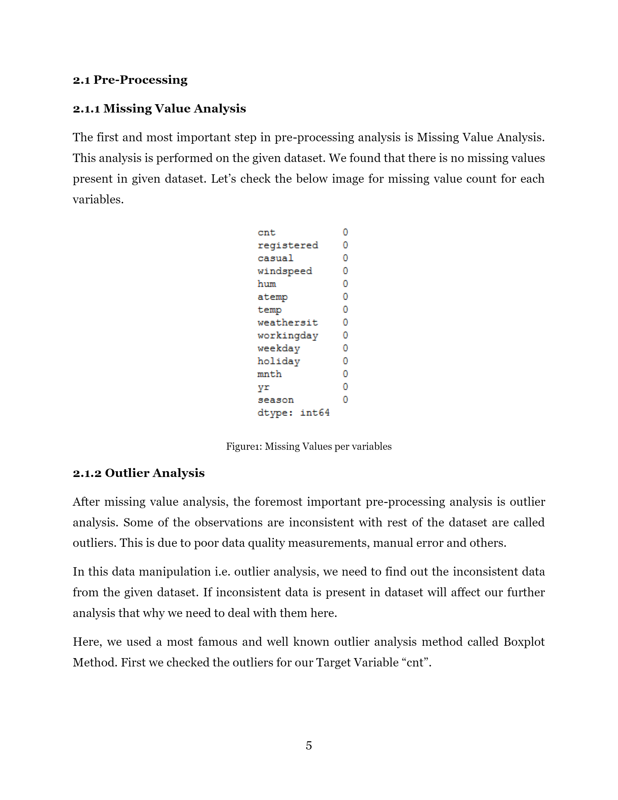

Figure1: Missing Values per variables

**2.1.2 Outlier Analysis**

After missing value analysis, the foremost important pre-processing analysis is outlier analysis. Some of the observations are inconsistent with rest of the dataset are called outliers. This is due to poor data quality measurements, manual error and others.

In this data manipulation i.e. outlier analysis, we need to find out the inconsistent data from the given dataset. If inconsistent data is present in dataset will affect our further analysis that why we need to deal with them here.

Here, we used a most famous and well known outlier analysis method called Boxplot Method. First we checked the outliers for our Target Variable “cnt”.

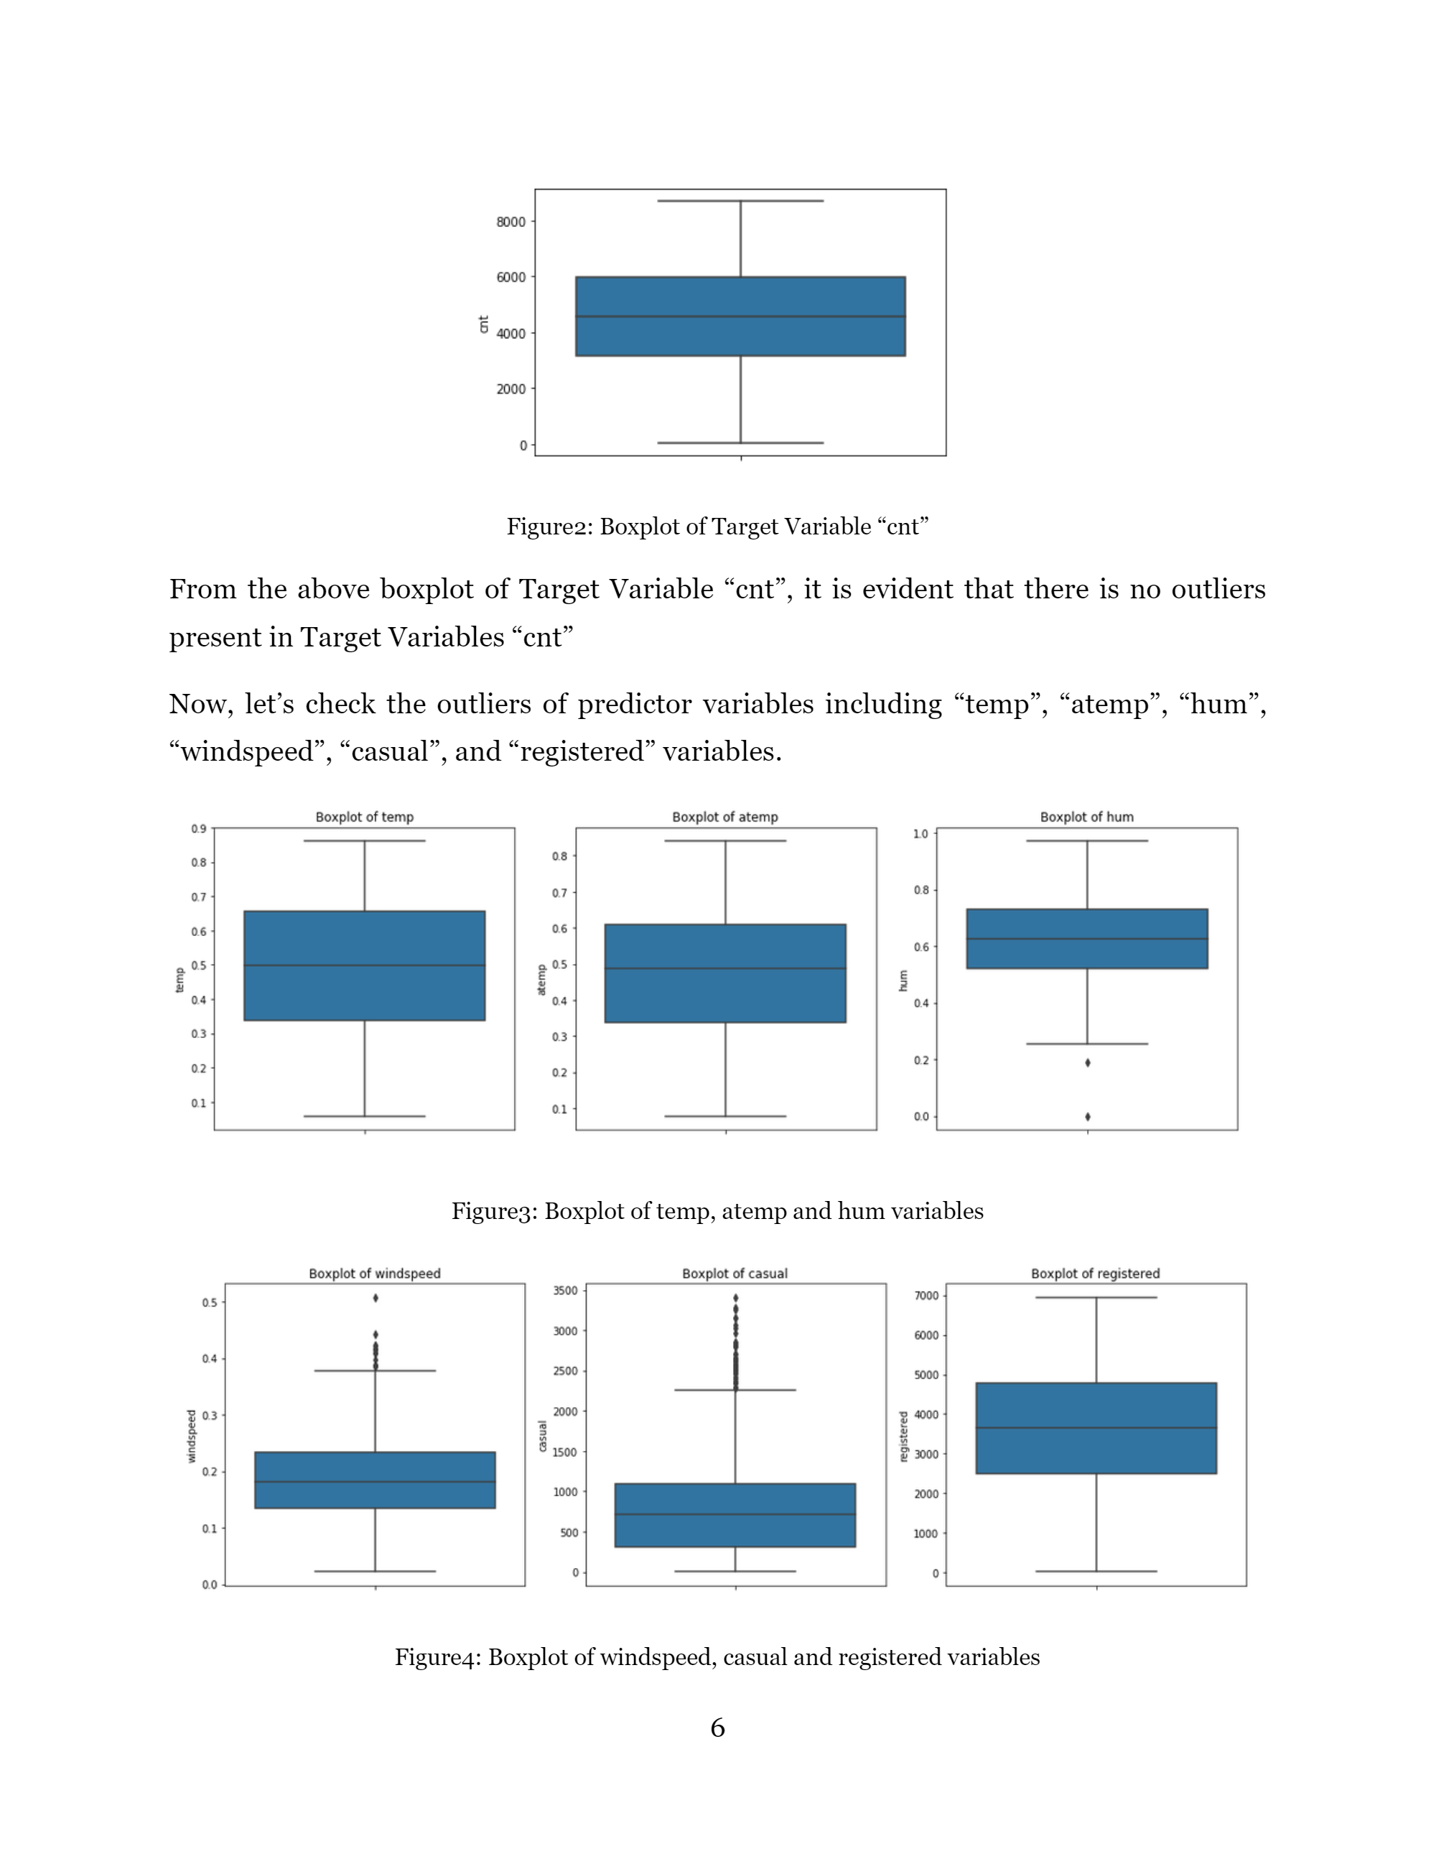

Figure2: Boxplot of Target Variable “cnt”

From the above boxplot of Target Variable “cnt”, it is evident that there is no outliers present in Target Variables “cnt”

Now, let’s check the outliers of predictor variables including “temp”, “atemp”, “hum”, “windspeed”, “casual”, and “registered” variables.



Figure4: Boxplot of windspeed, casual and registered variables

As the above image shows there are some outliers present in “hum”, “windspeed” and “casual” variables.

Here, we need to detect and delete the outliers that are present in “hum”, “windspeed” and “casual” variables using boxplot outlier removal method.

**2.1.3 Correlation Analysis**

Correlation Analysis is used to measure a linear relationship between two continuous variables. This analysis gives us an idea about the association between two continuous numerical variables. It is also used to check the muliticolinearity among predictors. Muliticolinearity is the condition when one predictor can be used to predict other. It is exist whenever two or more predictors in regression model are moderately or highly correlated.

Here we generate a correlation matrix and correlation plot

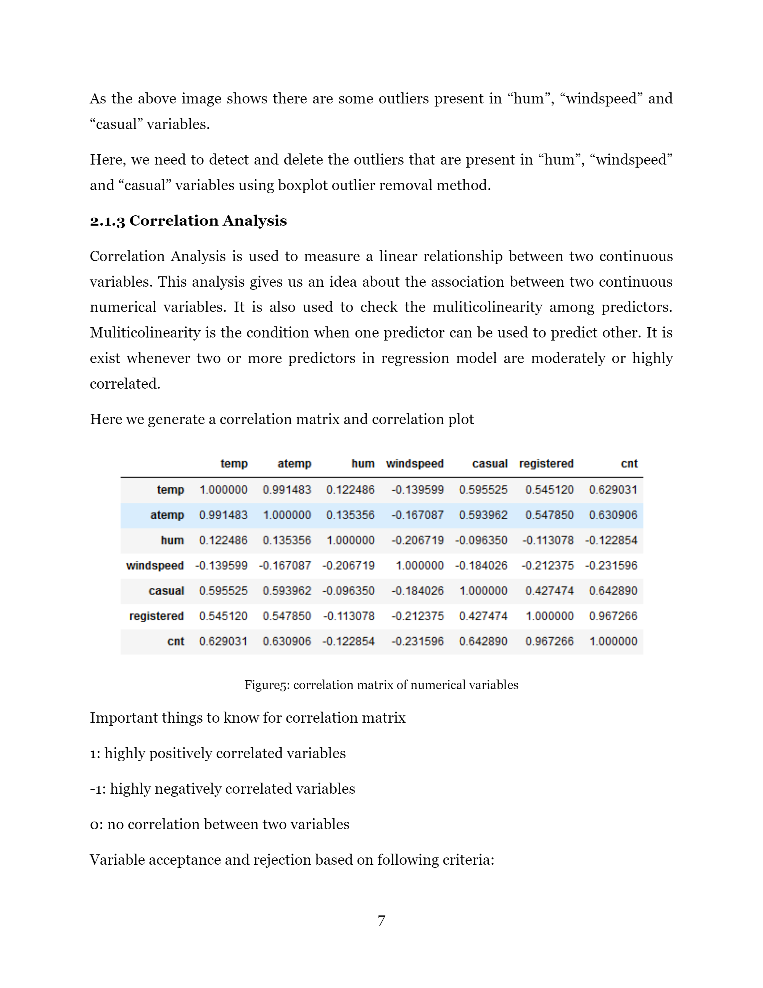

Figure5: correlation matrix of numerical variables

Important things to know for correlation matrix

1: highly positively correlated variables

-1: highly negatively correlated variables

0: no correlation between two variables

Variable acceptance and rejection based on following criteria:

* Correlation between two variables ranges from 0.7 to 1 and -1 to -0.7 then these variables, will not help to predict the final results, so you can drop any of the variable.
* Other than this accept these variables for model building.

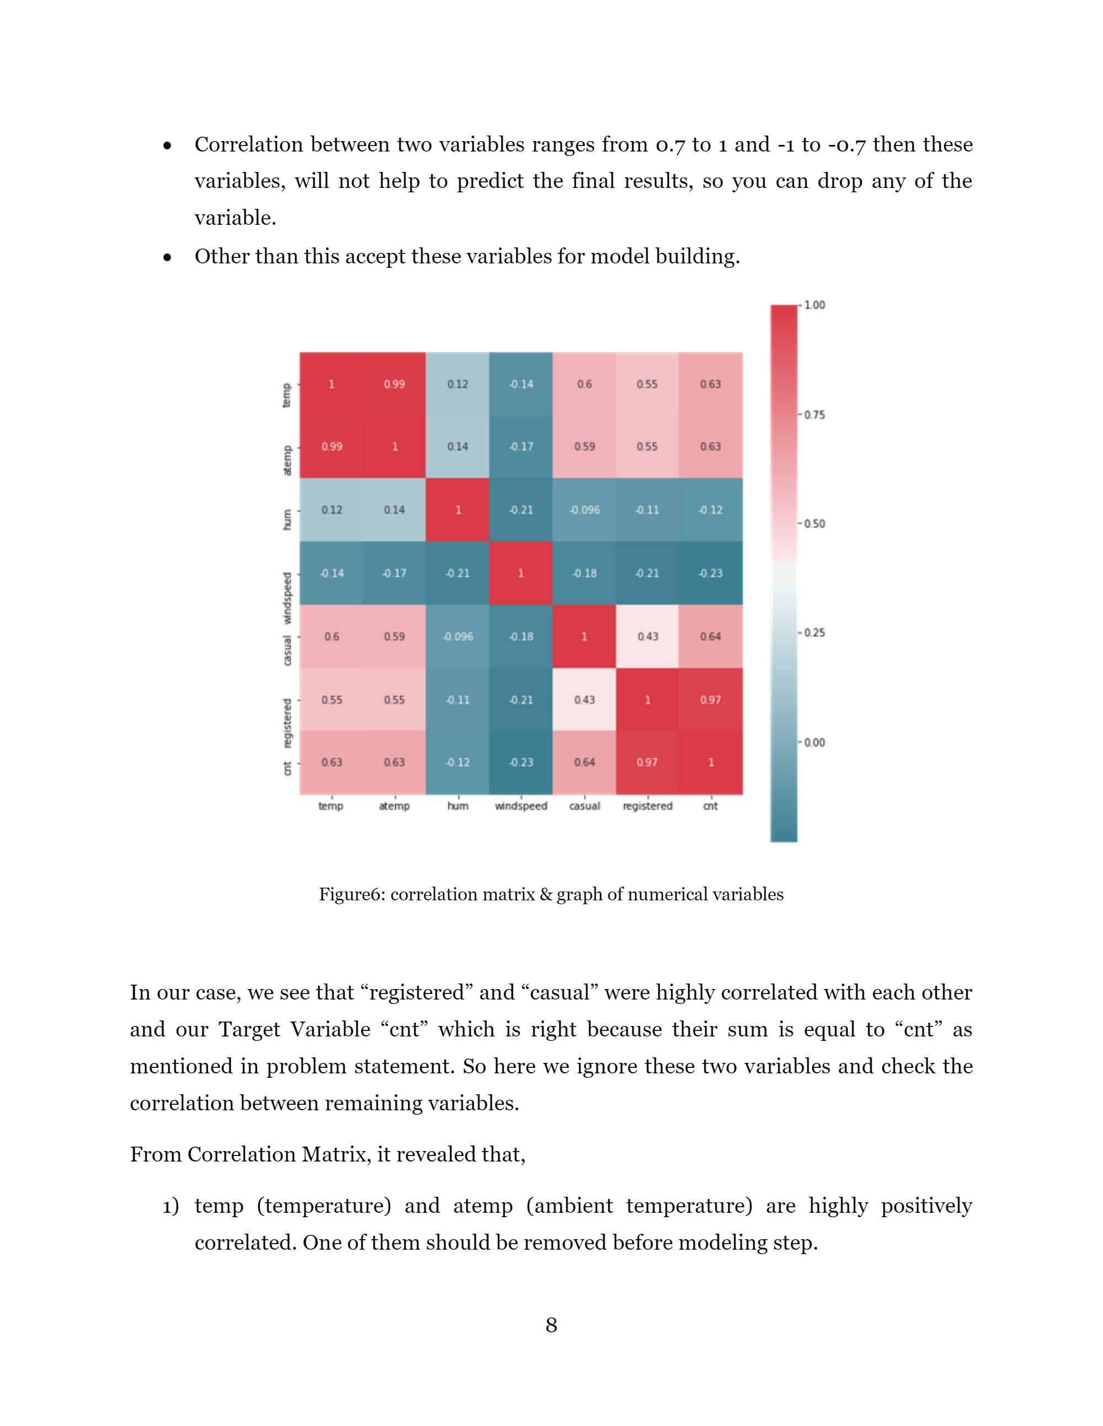

Figure6: correlation matrix & graph of numerical variables

In our case, we see that “registered” and “casual” were highly correlated with each other and our Target Variable “cnt” which is right because their sum is equal to “cnt” as mentioned in problem statement. So here we ignore these two variables and check the correlation between remaining variables.

From Correlation Matrix, it revealed that,

1) temp (temperature) and atemp (ambient temperature) are highly positively correlated. One of them should be removed before modeling step.

2) “cnt” has a positive and strong relationship with temp and atemp which is logical. People tends to rent more bikes when temperature is higher.

3) “cnt” has negative relationship with hum (humidity) and windspeed. People tends to rent less bike when there is more humidity and wind speed.

Here we drop the atemp variable as it highly positively correlated with temp variable.

**2.2 Exploratory Data Analysis**

**2.2.1 Bivariate Analysis**

In bivariate analysis, we check the relationship between our target variables and predictor variables. First we will check this for continuous variables.

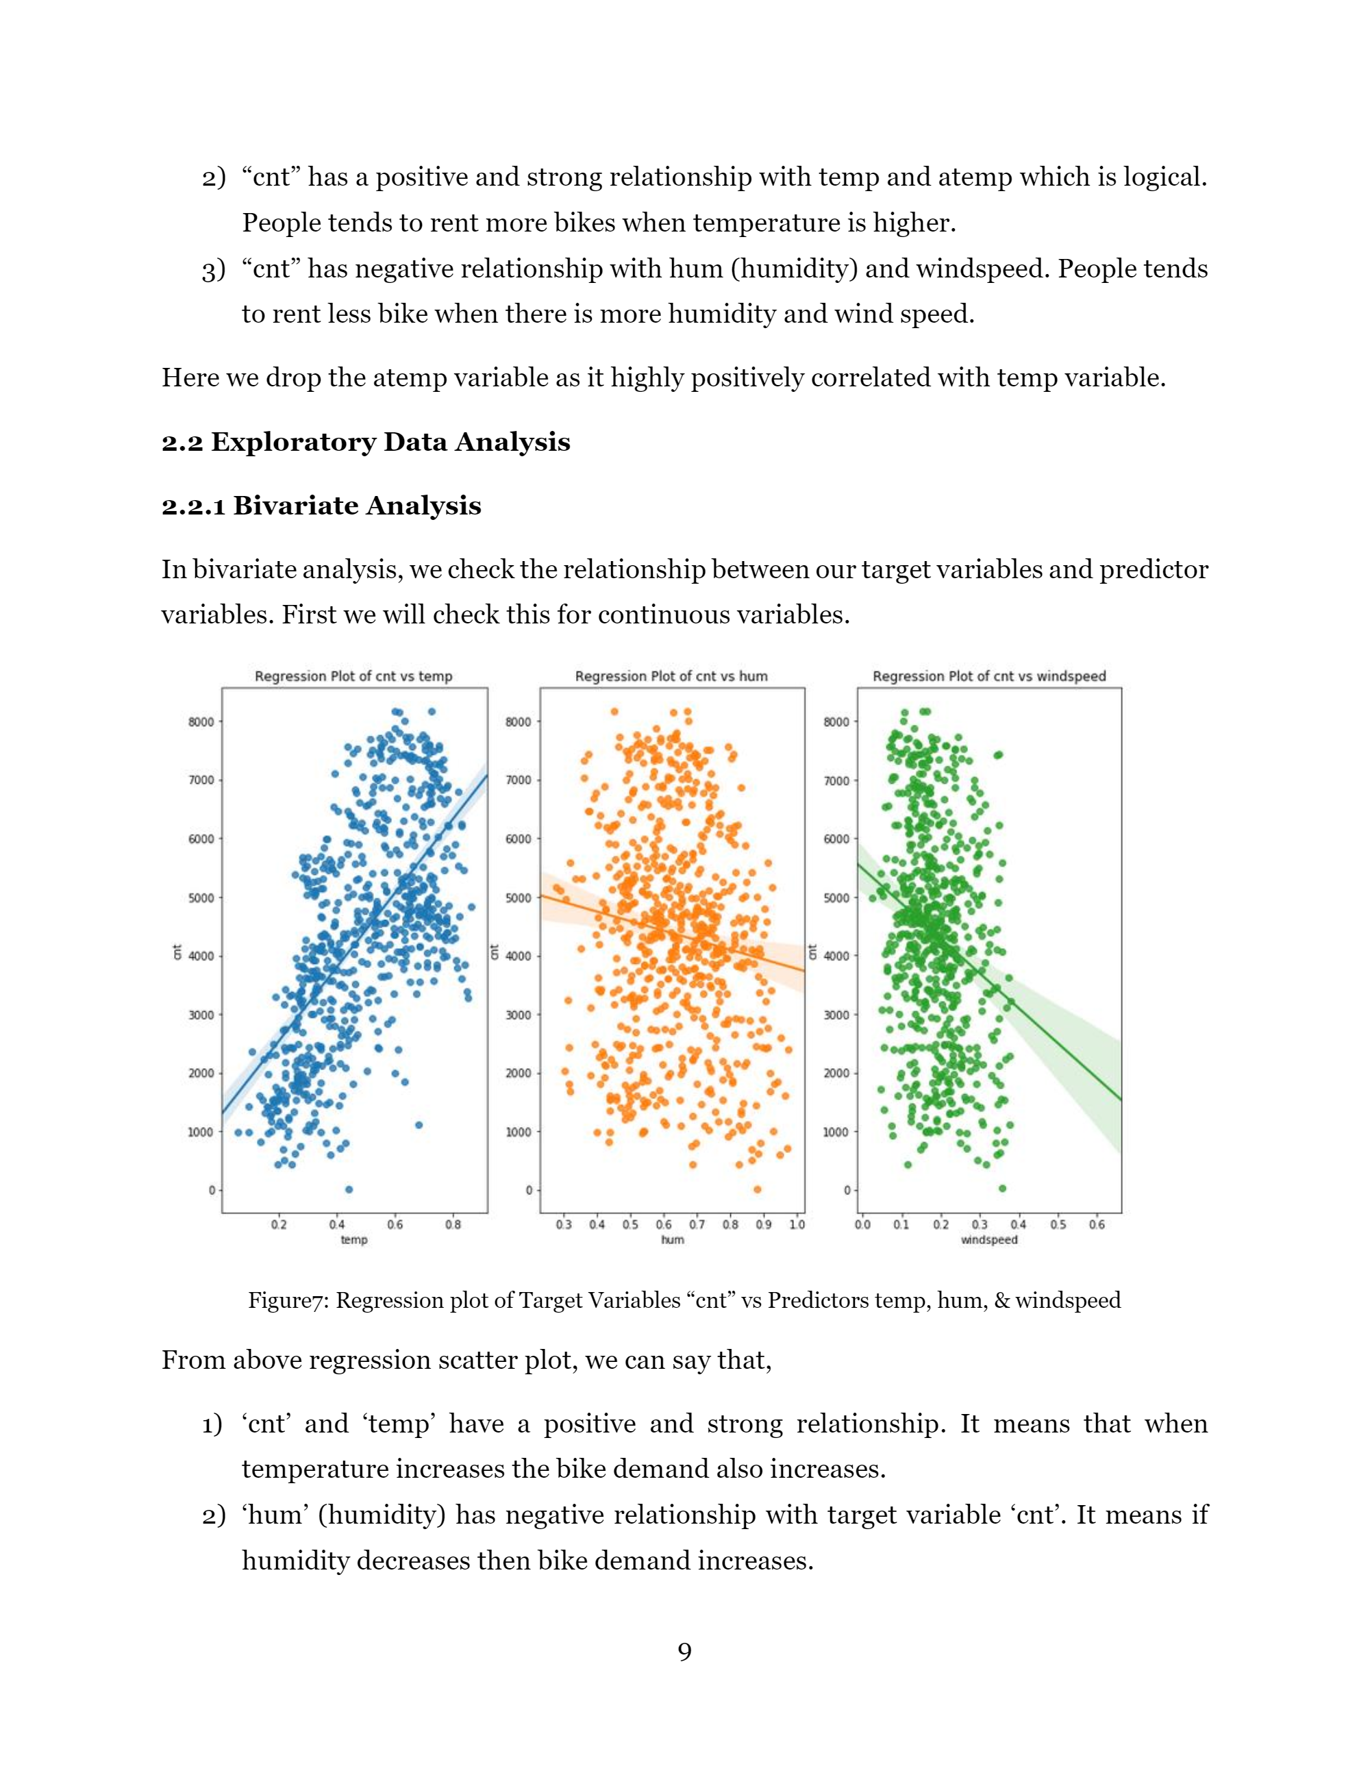Figure7: Regression plot of Target Variables “cnt” vs Predictors temp, hum, & windspeed

From above regression scatter plot, we can say that,

1) ‘cnt’ and ‘temp’ have a positive and strong relationship. It means that when temperature increases the bike demand also increases.

2) ‘hum’ (humidity) has negative relationship with target variable ‘cnt’. It means if humidity decreases then bike demand increases.

3) ‘windspeed’ and ‘cnt’ have negative linear relationship. It means that decrease in windspeed will increase bike demand.

Now, let’s see check the relationship between target variable and categorical variables using boxplot.

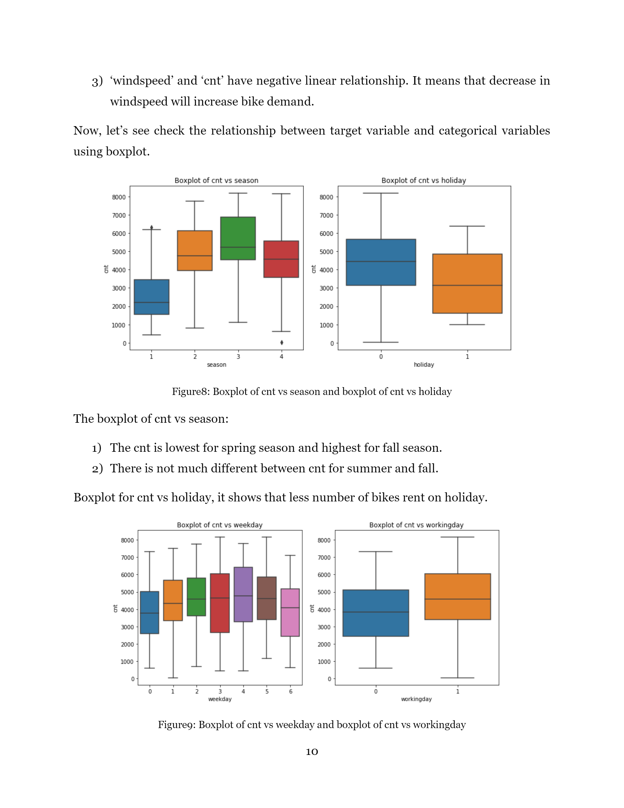

Figure8: Boxplot of cnt vs season and boxplot of cnt vs holiday

The boxplot of cnt vs season:

1) The cnt is lowest for spring season and highest for fall season.

2) There is not much different between cnt for summer and fall.

Boxplot for cnt vs holiday, it shows that less number of bikes rent on holiday.

Figure9: Boxplot of cnt vs weekday and boxplot of cnt vs workingday

The Boxplot of cnt vs weekday, there are nearly similar on all weekdays, but higher on Friday. Boxplot of cnt vs workingday, the more number of bikes are used on Workingday.

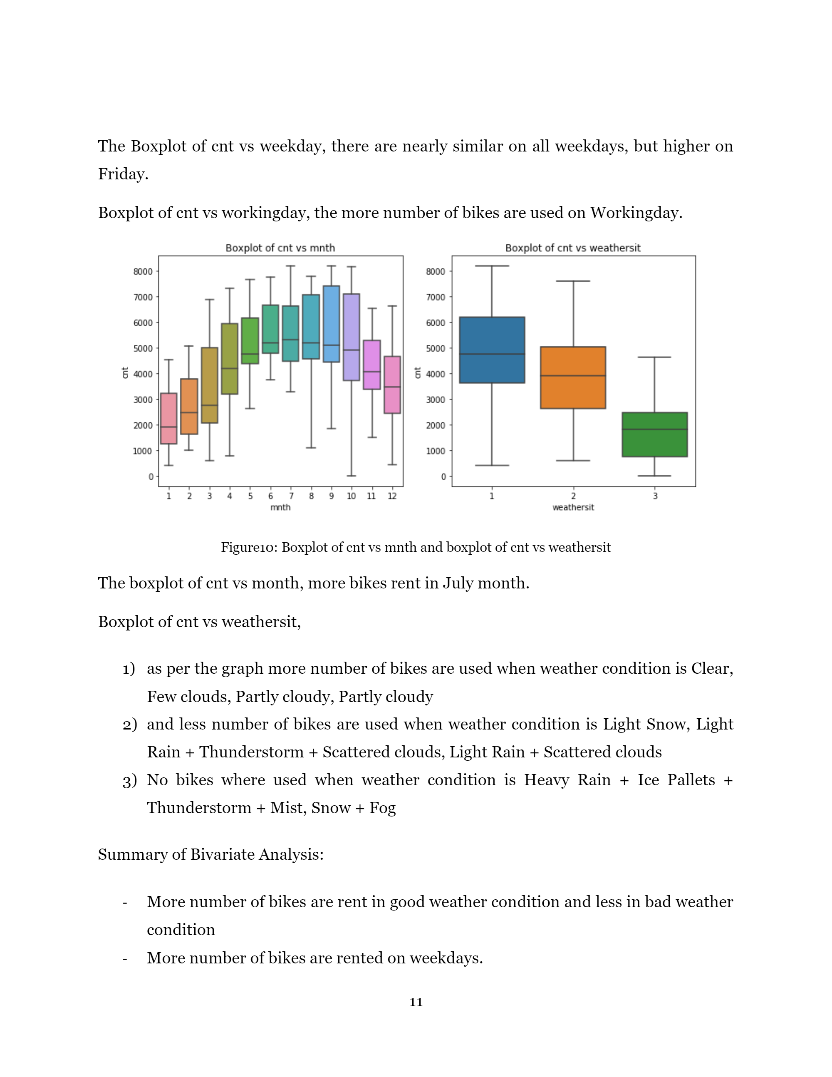Figure10: Boxplot of cnt vs mnth and boxplot of cnt vs weathersit

The boxplot of cnt vs month, more bikes rent in July month.

Boxplot of cnt vs weathersit,

1) as per the graph more number of bikes are used when weather condition is Clear, Few clouds, Partly cloudy, Partly cloudy

2) and less number of bikes are used when weather condition is Light Snow, Light Rain + Thunderstorm + Scattered clouds, Light Rain + Scattered clouds

3) No bikes where used when weather condition is Heavy Rain + Ice Pallets + Thunderstorm + Mist, Snow + Fog

Summary of Bivariate Analysis:

- More number of bikes are rent in good weather condition and less in bad weather condition

- More number of bikes are rented on weekdays.

**2.2.2 Feature Scaling**

Data Normalization is the process of rescaling one or more variables to the range of [0, 1], means smallest value of each variable is 0 and highest is 1. This is technique is a good to use when we know that our data distribution is not Gaussian.

As we know, the given dataset numerical variables are already normalized. To clarify using visualization techniques.

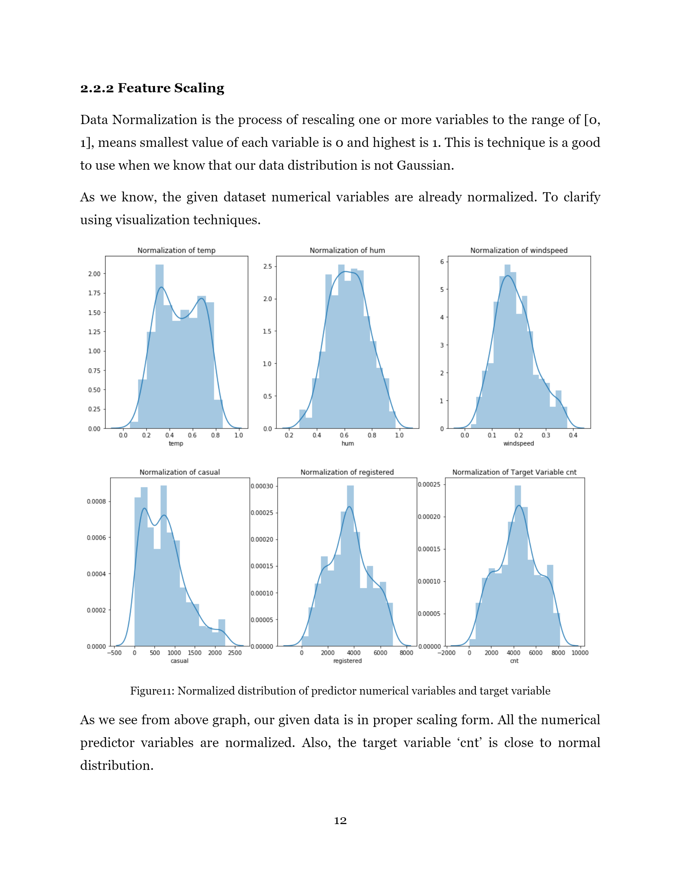Figure11: Normalized distribution of predictor numerical variables and target variable

As we see from above graph, our given data is in proper scaling form. All the numerical predictor variables are normalized. Also, the target variable ‘cnt’ is close to normal distribution.

**2.3 Modeling**

After pre-processing and exploratory data analysis, the data was divided into training and test dataset with 80% and 20% ratio. Now it’s time to implement various machine learning algorithms on our dataset.

In machine learning there is two main types:

* **Supervised Machine Learning:** knowledge of output. Target Variable is fix
* **Unsupervised Machine Learning**: No knowledge of Output. Self-Guided Learning Algorithms.

**2.3.1 Model Selection**

Selecting model is main Part of Modelling, We have various model algorithms some of the basic algorithms are:

* **Linear Regression :** Best suitable for Regression Model
* **Logistic Regression**: Suitable for Classification Model
* **Decision Tree**: Best suitable for Regression & Classification model
* **Random Forest**: Mostly used for Classification model analysis but can be used for Regression model
* **KNN algorithms:** Can be used for Regression and Classification model
* **Naive Bayes**: used for Classification Model

In our case of Bike Renting Prediction, we have to predict the number of bikes rent in single day based on environmental and seasonal conditions. The Target Variable ‘cnt’ is continuous in nature means we are dealing with regression problem.

That why, we are considering following machine learning algorithms

- Linear Regression

- Decision Tree Regression

- Random Forest Regression

- KNN Regression Algorithms.

**2.3.2 Linear Regression Model**

Linear Regression model is used to check the linear relationship between target variable and predictors.

Steps in Linear Regression Model:

1) Data is divided into train and test data in 80-20 ratio

2) Linear Regression is trained on train dataset.

3) Predict the output for test dataset by implementing trained linear regression model.

4) MAE, MSE, MAPE, and RMSE are used to check the performance of the model

Python Implementation

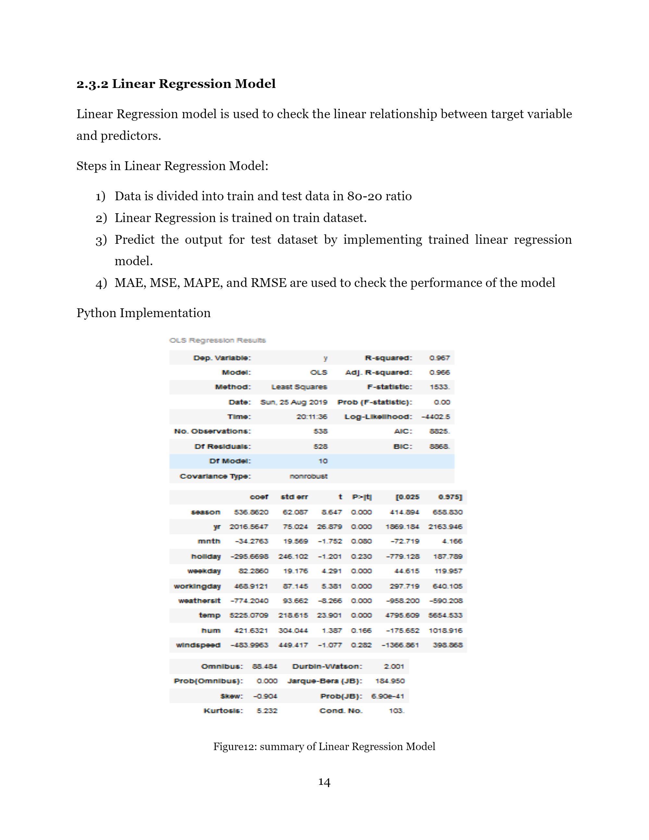

Figure12: summary of Linear Regression Model

Few things we learn from this output:

* season, yr, weekday, workingday, weathersit, temp have small p-values, whereas mnth, holiday, hum, windspeed have a larger p-values
* Here we reject the null-hypothesis for season, yr, weekday, workingday, weathersit, temp o There is assicoation between these variables and Target Variable cnt
* Fail to reject the null hypothesis for mnth, holiday, hum, windspeed o There is no association between these variables and Target Variable cnt

**R-squared (0.967)** means this model provides best fit for the given data

**2.3.3 Decision Tree Regression Model**

In decision tree regression algorithms the predictions is based on branching series of Boolean tests. There are number of different types of decision trees that can be used in Machine Learning Algorithms. Decision Tree is a rule. Each branch connects nodes with “and” and multiple braches are connected by “or”.

Steps in Decision Tree Regression Model:

1) Data is divided into train and test data in 80-20 ratio

2) Decision Tree Regression is trained on train dataset.

3) Predict the output for test dataset by implementing trained decision tree regression model. 4) MAE, MSE, MAPE, and RMSE are used to check the performance of the model

**2.3.4 Random Forest Regression Model**

Random Forest is an ensemble that consists of many decision trees. The method combines Breiman’s “bagging” idea and random selection of features. This algorithms can be used for regression problem

Steps in Random Forest Regression Model:

1) Data is divided into train and test data in 80-20 ratio

2) Random Forest Regression is trained on train dataset.

3) Predict the output for test dataset by implementing trained random forest regression model. 4) MAE, MSE, MAPE, and RMSE are used to check the performance of the model

**2.3.5 KNN Regression Algorithms**

K stands for K-Nearest Neighbors. It is the simple algorithms that scores all variable cases and classifies new cases based on similarity measures. It is the lazy learning algorithms

Steps in KNN Regression Model:

1) Data is divided into train and test data in 80-20 ratio

2) KNN Regression is trained on train dataset.

3) Predict the output for test dataset by implementing trained KNN forest regression model.

4) MAE, MSE, MAPE, and RMSE are used to check the performance of the model

**Chapter 3: Conclusion**

**3.1 Model Evaluation**

The Regression Model is evaluated by Error Metrics of Regression. There are various types of error measures to evaluate the model.

**Mean Absolute Error (MAE):** is the mean of the absolute value of the errors: In [0,∞), the smaller the better

**Mean Squared Error (MSE):** is the mean of the squared errors: In [0,∞), the smaller the better

**Mean Absolute Percent Error (MAPE):** is the mean of the absolute percent value of the errors: In [0,1), the smaller the better

**Root Mean Squared Error (RMSE) :**is the square root of the mean of the squared errors: In [0,∞), the smaller the better.

* MAE gives less weight to outliers means it is not sensitive to outliers.
* MAPE is similar to MAE, but normalized the true obeservations. When true observation is zero then this metric will be problematic
* MSE is a combination measurement of bias and variance of predictions. It is more popular.
* RSME is square Root of MSE, Root square is taken to make the units of the error be the same as the units of the target. This measure gives more weight to large deviations such as outliers, since large differences squared become larger and small (smaller than 1) differences squared become smaller.

**Selection**: Out-off these 4 error metrics, MSE and RMSE are mainly used for TimeSeries dataset. As we know, current working data is not a time dependent or time-series data.

For that Reason the Model Evaluation is based on **MAPE Error Metrics**

**3.2 Performance Measures**

**3.2.1 R Implementation**

For measuring the performance of various regression model, we considering MAPE Error Metrics using the metric package in R. Now we compare the MAPE for regression model

Table 3: Comparing MAPE Error Metrics in Various Regression Algorithms in R

|  |  |
| --- | --- |
| Model | MAPE |
| Linear Regression | 0.1684646 |
| Decision Tree Regression | 0.2316771 |
| Random Forest Regression | 0.1258508 |
| KNN Regression Algorithms | 0.2524476 |

From the above table, we see that Random Forest Regression performing better than other regression algorithms in MAPE error metrics.

**3.2.2 Python Implementation**

In python, MAPE error metric was calculated by creating MAPE function. Here no prebuilt package is available.

Table 4: Comparing MAPE Error Metrics in Various Regression Algorithms in Python

|  |  |
| --- | --- |
| Model | MAPE |
| Linear Regression | 0.17278869 |
| Decision Tree Regression | 0.26101719 |
| Random Forest Regression | 0.12905417 |
| KNN Regression Algorithms | 0.18841675 |

Model MAPE Linear Regression 0.17278869 Decision Tree Regression 0.26101719 Random Forest Regression 0.12905417 KNN Regression Algorithms 0.18841675

As we see, Random Forest Regression performing better than other regression algorithms.

**3.3 Model Selection**

From the error metric we can see that Random Forest Regression is performing better than other regression algorithms in both R and Python. The result we get for Random Forest Regression is somewhat similar in both R and Python. But R implementation is performing better than python for linear, decision tree and random tree regression algorithms.

The final model selection, we will go with the Random Forest Regression Model to get more precise predictions as they have low MAPE error metrics.

**Appendix**

**R Implementation graph plot**

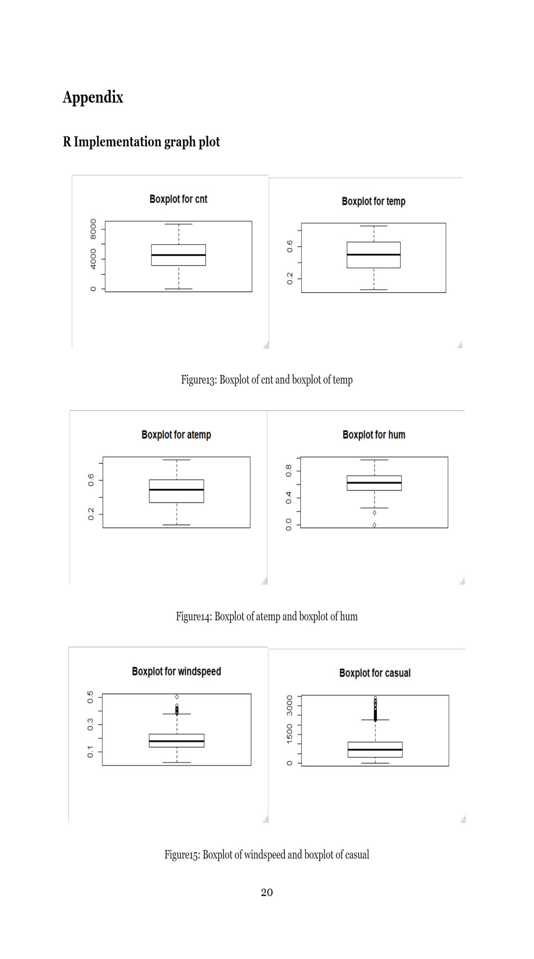

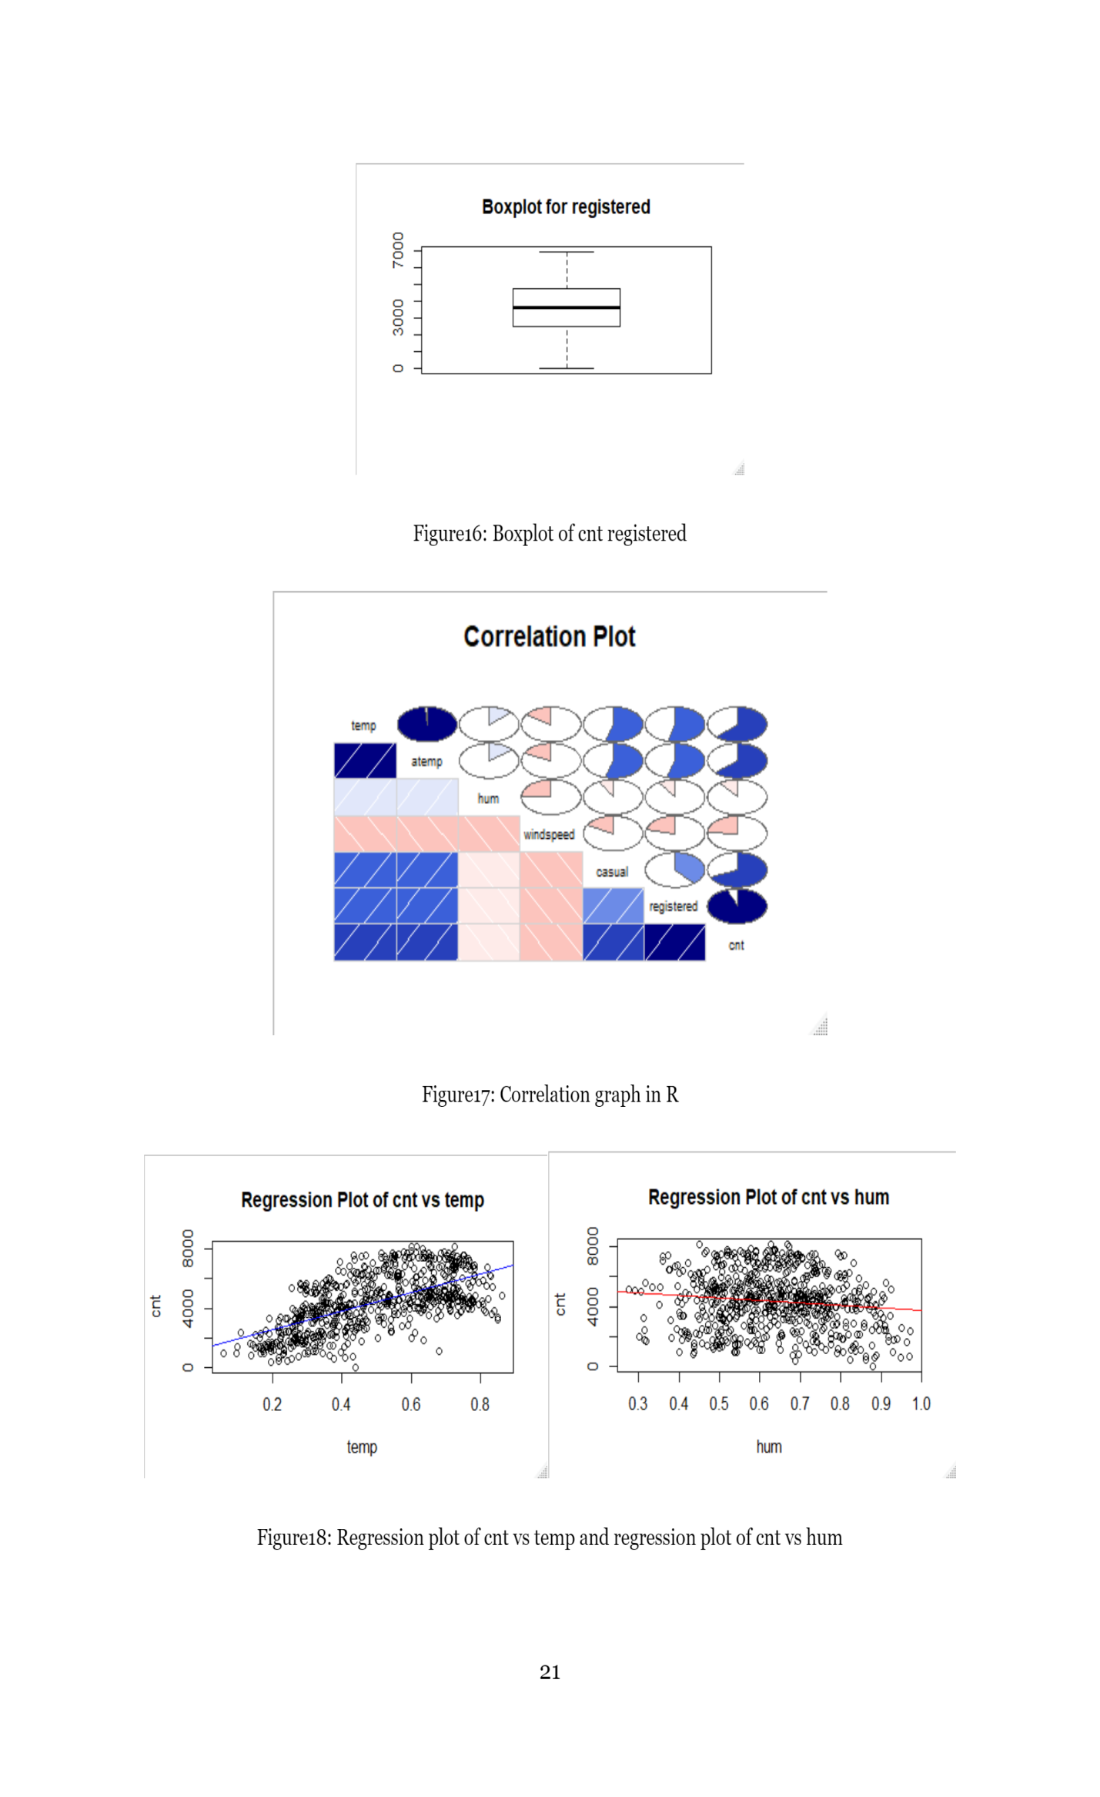

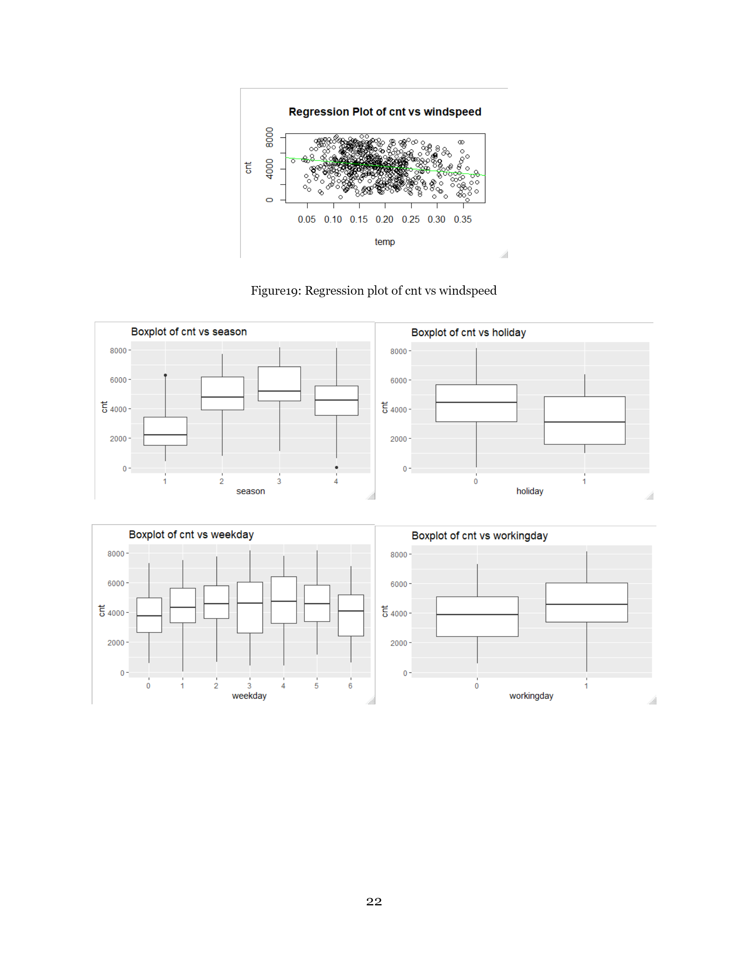

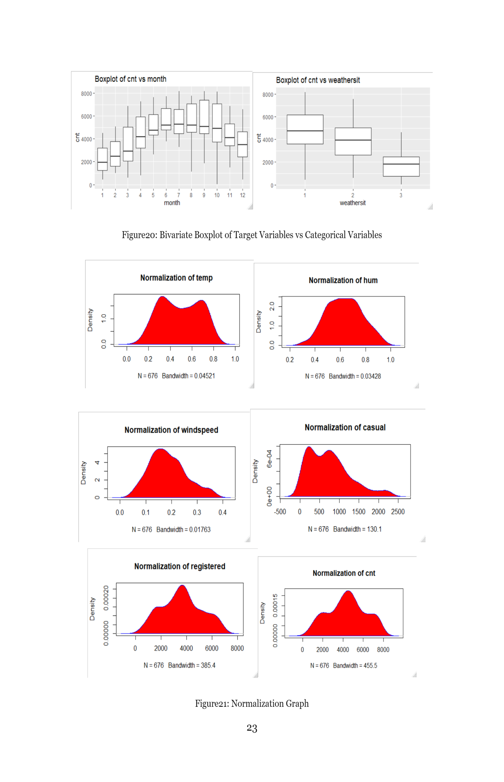

**Code**

**R Implementation Code**

#remove all program/objects from RAM

rm(list=ls())

#set Working directory

setwd("D:/Bike Renting")

#cheking current working directory

getwd()

#before starting this project with dataset.

#Initially I open given file in excel and just look the data available

#starting the project We need to load some libraries to deal with this data

install.packages(c("lattice", "dplyr", "plyr", "ggplot2", "corrgram"))

install.packages("contrib.url")

#install required libraries

library("dplyr")

library("plyr")

library("ggplot2")

library("corrgram")

library("lattice")

#load required dataset

data = read.csv("day.csv", header = T)

###################################################################################################

# Understanding the data

##################################################################################################

#after loading the dataset

#let's check the number of variables and obseravtions in dataset

dim(data)

#we see that there are 731 observations(Rows) and 16 variables(Columns) in given dataset.

#checking first few rows of data

head(data,10)

#in this "cnt" is our Target Variable and others are predictor variables

#check the summary of the data

summary(data)

#it shows that varable like "yr", "mnth", "holiday", "weekday", "workingday", "weathershit"

#are categorical variables and already encoded.

#numerical variables like "temp", "atemp", "hum", windspeed" are already converted into

#noramlized form as that mentioned into problem statement.

#cheking data structure

str(data)

#as categorical variables shows the int datatypes. So we need to convert them into proper datatype

#i.e. factor variable

#changing dtype of categotical variables

data$season = as.factor(data$season)

data$yr = as.factor(data$yr)

data$mnth = as.factor(data$mnth)

data$holiday = as.factor(data$holiday)

data$weekday = as.factor(data$weekday)

data$workingday = as.factor(data$workingday)

data$weathersit = as.factor(data$weathersit)

#checking data structure again

str(data)

#in this dataset, some of the variables are not useful for further analysis for that reason

#we going to dropped that variables

######### Dropping Variables which are not required

############## instant: index number which is not useful in analysis

############## dteday: all required parameters are already extracted from this variable such as

####################### yr, mth, weekday. So this variable is not useful

#dropping instant & dteday variables

data = select(data, -c(instant, dteday))

#check dataset after dropping variables

dim(data)

head(data,10)

###################################################################################################

#Missing Value Analysis

##################################################################################################

#checking number of missing values in dataset

sum(is.na(data))

#checking variables with missing values count

sapply(data, function(x) sum(is.na(x)))

#there is no missing values in dataset

##################################################################################################

#Outlier Analysis

##################################################################################################

#here, we use Boxplot Method to visualize the ouliers in our dataset

#plotting boxplot for "cnt" variable

boxplot(data$cnt, data=data, main = "Boxplot for cnt")

#after checking the Boxplot for cnt, it is evident that there is no outlier present in cnt

#let's check the outliers of predictor variables such as temp, atemp, hum, winspeed, casual, registered

#plotting boxplot for "temp" variable

boxplot(data$temp, data=data, main = "Boxplot for temp")

#no outliers in temp variable

#plotting boxplot for "atemp" variable

boxplot(data$atemp, data=data, main = "Boxplot for atemp")

#no outliers in atemp variable

#plotting boxplot for "hum" variable

boxplot(data$hum, data=data, main = "Boxplot for hum")

#outliers preset in hum variable, that we will remove after checking all variables ouliter

#plotting boxplot for "windspeed" variable

boxplot(data$windspeed, data=data, main = "Boxplot for windspeed")

#outliers preset in windspeed variable, that we will remove after checking all variables ouliter

#plotting boxplot for "causal" variable

boxplot(data$casual, data=data, main = "Boxplot for casual")

#outliers preset in casual variable, that we will remove after checking all variables ouliter

#plotting boxplot for "registered" variable

boxplot(data$registered, data=data, main = "Boxplot for registered")

#no outliers in registered variable

#as we see there are some outliers present in "hum", "windspeed" and "casual" variables

#varaibles hum, windspeed, casual has ouliers and that have to be remove by

#outlier removal method

#make copy of data if anything wrong goes

df = data

data =df

########### Treating Outliers ##############################

#findout the numeric variables in dataset

numeric_index = sapply(data, is.numeric)

#prepare the numeric dataset

numeric_data = data[, numeric_index]

cnames = colnames(numeric_data)

#loop to remove outliers from all variables

for(i in cnames){

qnt = quantile(data[i], probs = c(.75, .25), na.rm = T)

iqr = qnt[1] - qnt[2]

min = qnt[2] - (iqr*1.5)

max = qnt[1] + (iqr*1.5)

print(min)

print(max)

data = subset(data, data[i]>min)

data = subset(data, data[i]<max)

}

#there are 55 observations are dropped in outliers

#################################################################################################

#correlation Analysis

#################################################################################################

#Correlation Analysis: Here we generating correlation matrix to understand

#how the each variable related with each other. In that we plotting correlation matrix

#and generate plot using corrgram library for better understanding

#this metrix wil be plot only using numeric data for that we provide numeric data

corr = cor(numeric_data)

print(corr)

#plotting correlation plot using corrgram library

corrgram(numeric_data, order = F, upper.panel = panel.pie, text.panel = panel.txt, main = "Correlation Plot")

#The above correlation analysis shows that,

#temp and atemp are highly correlated

#temp and atemp have positive and strong correlation with cnt

#hum and windspeed have negative and weak correlation with cnt

#dropping atemp variable from a dataset

data = select(data, -c(atemp))

#################################################################################################

# Exploratory Data Analysis

#################################################################################################

################################ Bivariate Analysis ############################################

#finding the relationship between Numerical variables "temp", "hum", "windspeed" with

#target variable cnt

#relation between cnt vs temp

attach(data)

plot(temp, cnt, main="Regression Plot of cnt vs temp",

xlab="temp", ylab="cnt")

abline(lm(cnt~temp), col="blue") # regression line (y~x)

#relation between cnt vs hum

plot(hum, cnt, main="Regression Plot of cnt vs hum",

xlab="hum", ylab="cnt")

abline(lm(cnt~hum), col="red") # regression line (y~x)

#relation between cnt vs windspeed

plot(windspeed, cnt, main="Regression Plot of cnt vs windspeed",

xlab="temp", ylab="cnt")

abline(lm(cnt~windspeed), col="green") # regression line (y~x)

#after plotting above graph, we see that

### cnt has positive linear relationship with temp

### on the otherside, cnt has negative linear relationship with windspeed

### but hum(humidity) has a little neagive relationship with cnt

#now let's find the relationship between categorical variables and Target Variables "cnt"

#categorical variables are "season", "holiday", "weekday", "Workingday", "weathershit", "month"

#plotting boxplot for cnt vs season variable

ggplot(data, aes(x=season, y=cnt)) +

geom_boxplot()+xlab("season")+ylab("cnt")+ggtitle("Boxplot of cnt vs season")

##cnt is very low in Spring Season and cnt is large in Fall Season

#plotting boxplot of cnt vs holiday

ggplot(data, aes(x=holiday, y=cnt)) +

geom_boxplot()+xlab("holiday")+ylab("cnt")+ggtitle("Boxplot of cnt vs holiday")

##cnt is more on weekday i.e. no holiday

#plotting boxplot of cnt vs weekday

ggplot(data, aes(x=weekday, y=cnt)) +

geom_boxplot()+xlab("weekday")+ylab("cnt")+ggtitle("Boxplot of cnt vs weekday")

#as per the graph more number of bikes are used on Friday

#plotting boxplot of cnt vs workingday

ggplot(data, aes(x=workingday, y=cnt)) +

geom_boxplot()+xlab("workingday")+ylab("cnt")+ggtitle("Boxplot of cnt vs workingday")

#as per the graph more number of bikes are used on Workingday,

#this conclusion we already get from boxplot of cnt vs holiday

#plotting boxplot of cnt vs month

ggplot(data, aes(x=mnth, y=cnt)) +

geom_boxplot()+xlab("month")+ylab("cnt")+ggtitle("Boxplot of cnt vs month")

#as per the graph more number of bikes are used in July Month of year

#plotting boxplot of cnt vs weathersit

ggplot(data, aes(x=weathersit, y=cnt)) +

geom_boxplot()+xlab("weathersit")+ylab("cnt")+ggtitle("Boxplot of cnt vs weathersit")

#1 >>as per the graph more number of bikes are used when weather condition is Clear, Few clouds,

#Party cloudy, Partly cloudy

#2 >> and less number of bikes are used when weather condition is

#Light Snow, Light Rain + Thunderstorm + Scattered clouds, Light Rain + Scattered clouds

#3 >> No bikes where used when weather condition is

#Heavy Rain + Ice Pallets + Thunderstorm + Mist, Snow + Fog

##########Summary#############

## cnt is maximum in good weather condition and minimum in bad weather condition

## more number of bikes are rented on weekdays.

##################################################################################################

#Feature Scalling

##################################################################################################

#as we know that, most of given variables are already Normalised

#But let's clarify that using Visualization techniques

#check whether variable "temp" is normal or not

plot(density(data$temp), main="Normalization of temp")

polygon(density(data$temp), col="red", border="blue")

#check whether variable "hum" is normal or not

plot(density(data$hum), main="Normalization of hum")

polygon(density(data$hum), col="red", border="blue")

#check whether variable "windspeed" is normal or not

plot(density(data$windspeed), main="Normalization of windspeed")

polygon(density(data$windspeed), col="red", border="blue")

#check whether variable "casual" is normal or not

plot(density(data$casual), main="Normalization of casual")

polygon(density(data$casual), col="red", border="blue")

#checking whether varianle "registered" is normal or not

plot(density(data$registered), main="Normalization of registered")

polygon(density(data$registered), col="red", border="blue")

#checking whether variable "cnt" is normal or not

plot(density(data$cnt), main="Normalization of cnt")

polygon(density(data$cnt), col="red", border="blue")

#As we can see, our data is in proper scalling form. Numerical Predictor Variables are Normalized

#Also our Target Variable 'cnt' is also close to Normal Distribution

#################################################################################################

#Modeling & Prediction

#################################################################################################

##Data Cleaning is done! Now lets bulid the model and predict the results

#In machine Learning there is Two main types:

#Supervised Machine Learning : knowledge of output. Target Variable is fix

#Unsupervised Machine Learning: No knowledge of Output. Self Guided Learnig Algorithms.

#Selecting model is main Part of Modelling, We have various model algorithms some of

#the basic algorithms are:

#Linear Regression : Best suitable for Regression Model

#Logistic Regression: Suitable for Classification Model

#Decision Tree: Best suitable for Regression & Classification model

#Random Forest: Mostly used for Classification model analysis but can be use for Regression model

#KNN algorithms: Can be used for Regression and Classification model

#Naive Bayes: used for Classification Model

#in our given dataset, Target Variable "cnt" is Numerical Continuous Variable. So we are dealing

#with Regression Model Analysis.

#for that reason we are considering following algorithms

#1 >> Linear Regression

#2 >> Decision Tree

#3 >> Random Forest

#4 >> KNN Algorithms

#before moving further let's droped the casual and registered variables because there sum is

#equal to target variable i.e. "cnt"

data = select(data, -c(casual, registered))

#Now to predict the model, to simulate a train and test set, we are going to split randomly

#this train dataset into 80% train and 20% test.

df1 = data

#Random Sample indexes

train_index = sample(1:nrow(data), 0.8*nrow(data))

test_index = setdiff(1:nrow(data), train_index)

#Build train_X, train_y, test_X, test_y

train_X = data[train_index, -11]

train_y = data[train_index, "cnt"]

test_X = data[test_index, -11]

test_y = data[test_index, "cnt"]

#################################################################################################

#Linear Regression Model

#################################################################################################

install.packages("usdm")

library(usdm)

model_LR = lm(train_y ~ ., data=train_X)

summary(model_LR)

#predict the output for test_X dataset

predict_LR = predict(model_LR, test_X)

#A few things, we learn from this output

#season, yr, weekday, workingday, weathersit, temp have small p-values,

#where as mnth, holiday, hum, windspeed have a larger p-values

#Here we reject the null-hypothesis for season, yr, weekday, workingday, weathersit, temp

#There is assicoation between these variables and Target Variable cnt

#Fail to reject the null hypothesis for mnth, holiday, hum, windspeed

#There is no association between these variables and Target Variable cnt

#R-squared (0.8652) means this model provides best fit for the given data

#but Selecting the model with the highest R-squared is not a

#reliable approach for choosing the best linear model.

#####Better Solution is###########

#Do model Evaluation based on the Error Metrics for Regression:

#For classification problems, we have only used classification accuracy as our evaluation metric.

#But here we used Error Metrics to evaluate the model

#Mean Absolute Error (MAE): is the mean of the absolute value of the errors:

#In [0,???), the smaller the better

#Mean Squared Error (MSE): is the mean of the squared errors: In [0,???), the smaller the better

#Mean Absolute Percent Error (MAPE): is the mean of the absolute percent value of the errors:

#In [0,1), the smaller the better

#Root Mean Squared Error (RMSE) :is the square root of the mean of the squared errors:

#In [0,???), the smaller the better

#Let's calculate these by hand, to get an intuitive sense for the results:

install.packages("Metrics")

library(Metrics)

# calculate MAE, MSE, MAPE, RMSE

mae(test_y, predict_LR) #503.6793

mse(test_y, predict_LR) #473119.3

mape(test_y, predict_LR) #0.1684646

rmse(test_y, predict_LR) #687.8367

####

#MAE gives less weight to outliers means it is not sensitive to outliers.

#MAPE is similar to MAE, but normalized the true obeservations. When true observation is zero

#then this metric will be problematic

#MSE is a combination measurement of bias and variance of predictions. It is more popular.

#RSME is square Root of MSE, Root square is taken to make the units of the error be the same as

#the units of the target. This measure gives more weight to large deviations such as outliers,

#since large differences squared become larger and small (smaller than 1)

#differences squared become smaller.

#Selection: Outoff these 4 error metrics, MSE and RMSE are mainly used for Time-Series dataset.

#As I know, current working data is not a time dependend or time-series data.

#for that Reason the Model Evaluation is based on MAPE Error Metrics

################################################################################################

#Decision Tree

################################################################################################

#load libraries

library(rpart)

library(MASS)

#use rpart for Decision Tree regression

model_DT = rpart(train_y ~ ., data=train_X, method = "anova")

summary(model_DT)

#predict the output for test_X dataset

predict_DT = predict(model_DT, test_X)

# calculate MAE, MSE, MAPE, RMSE

mae(test_y, predict_DT) #652.6066

mse(test_y, predict_DT) #722906.5

mape(test_y, predict_DT) #0.2316771

rmse(test_y, predict_DT) #850.2391

################################################################################################

#Random Forest

################################################################################################

#load libraries

library(randomForest)

#use randomForest for Random Forest regression

model_RF = randomForest(train_y ~ ., data=train_X, importance = TRUE, ntree = 50)

summary(model_RF)

#predict the output for test_X dataset

predict_RF = predict(model_RF, test_X)

# calculate MAE, MSE, MAPE, RMSE

mae(test_y, predict_RF) #295.5393

mse(test_y, predict_RF) #207524.9

mape(test_y, predict_RF) #0.1258508

rmse(test_y, predict_RF) #455.549

################################################################################################

#KNN Algorithms

################################################################################################

#load library

library(caret)

#use knnreg for KNN regression algorithms

model_KNN = knnreg(train_y ~.,data=train_X, k=5)

summary(model_KNN)

#predict the output for test_X dataset

predict_KNN = predict(model_KNN, test_X)

# calculate MAE, MSE, MAPE, RMSE

mae(test_y, predict_KNN) #735.0471

mse(test_y, predict_KNN) #866782.7

mape(test_y, predict_KNN) #0.2524476

rmse(test_y, predict_KNN) #931.0117

#################################################################################################

#Selecting Best Fit model for Future Analysis

################################################################################################

#We are cosidering the MAPE for model evaluation becasue,

#it calculate average absolute percent error for

#each time period minus actual values divided by actual values.

#Reason we already discussed, let's explain again:

####Selection: Outoff these 4 error metrics,

#MSE and RMSE are mainly used for Time-Series dataset. As we know,

#current working data is not a time dependend or time-series data.

#Random Forest Model has smallest error metrics i.e.

# MAPE = 0.1258508

#So, for further analysis We are selecting Random Forest Model.